Malebo Clementine Mphahlele
St10370740
HCIN6222
Part 2
25 May 2026
Live Link: studytrackap.netlify.app

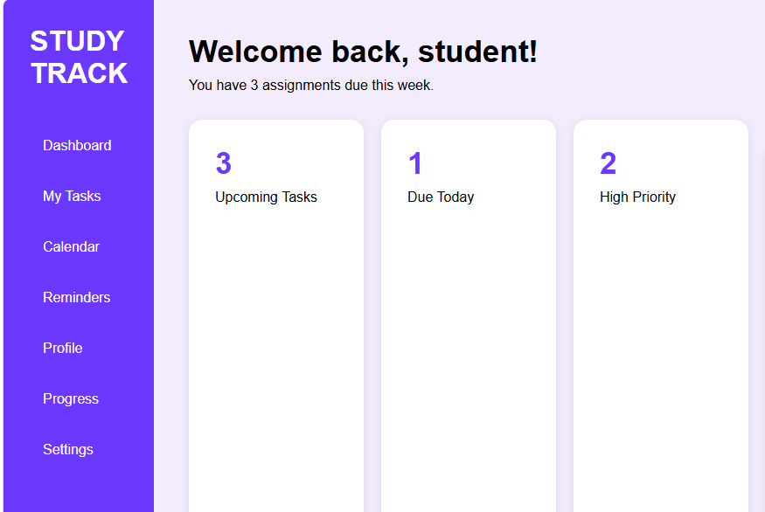
Figure 1: Study Track Dashboard Homepage
The dashboard homepage provides students with quick access to tasks, reminders, Settings and progress tracking features in one interface.
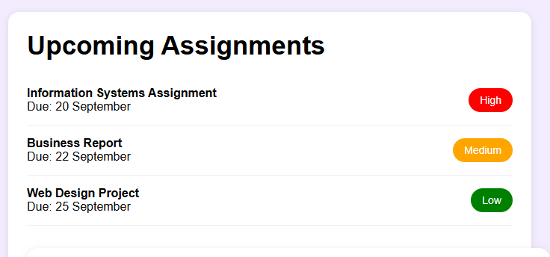
Figure 2: Upcoming Assignments Interface
The assignments section helps students manage upcoming academic tasks by displaying due dates and priority levels.
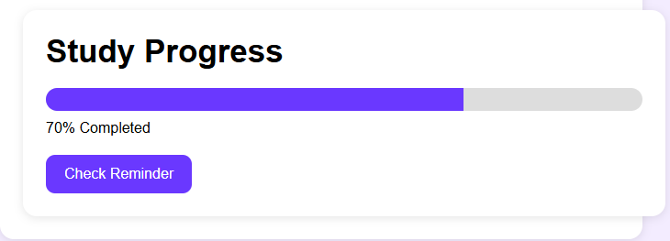
Figure 3: Student Progress Tracking Feature
The progress tracking feature visually displays the student’s academic completion percentage to encourage motivation and productivity.

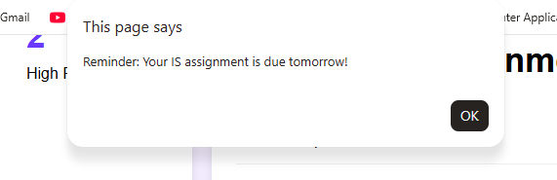
Figure 4: Reminder Notification Interaction
The reminder notification interaction uses JavaScript to provide alerts about important assignment deadlines and improve user interaction.
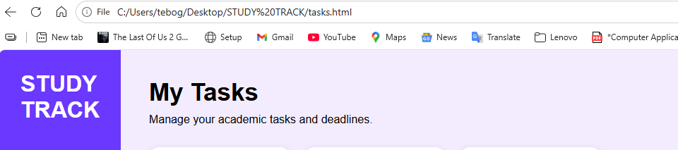
Figure 5: My task page
The Tasks page enables students to manage academic activities and monitor important coursework tasks within the Study Track system.

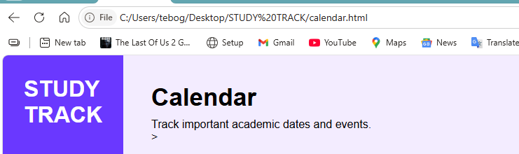
Figure 6: My calendar page
The Calendar page provides students with access to important academic dates, schedules and upcoming events in an organised format.
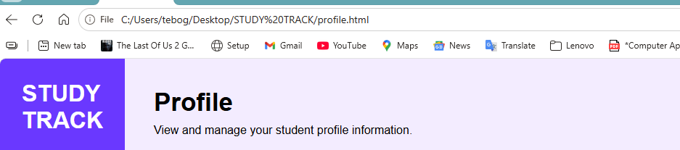
Figure 7: My profile page
The Profile features allow students to personalise their dashboard experience and manage their personal academic information.

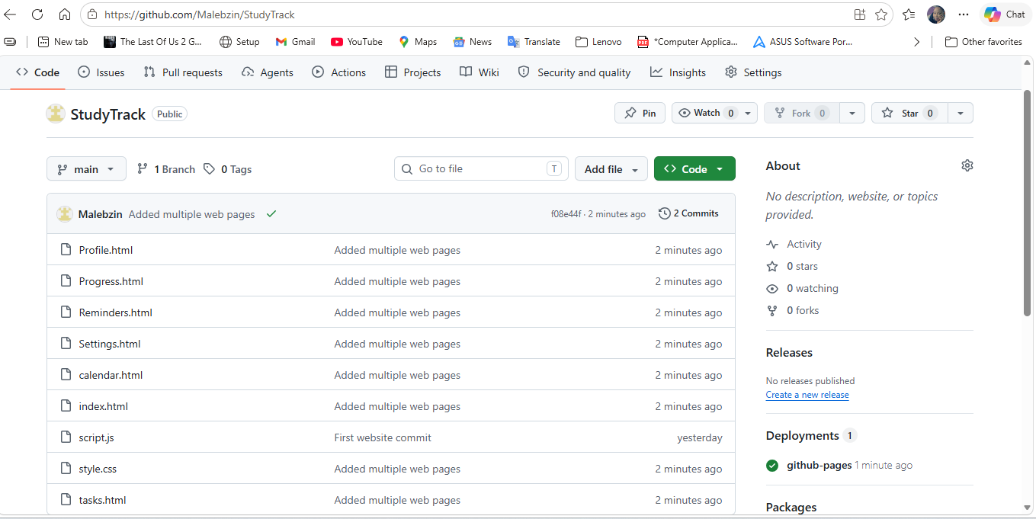
Figure 8: Study Track GitHub Repository and Multi-Page Website Files
The repository contains the HTML, CSS and JavaScript files used to develop the interactive multi-page student dashboard website prototype. https://github.com/Malebzin/StudyTrack

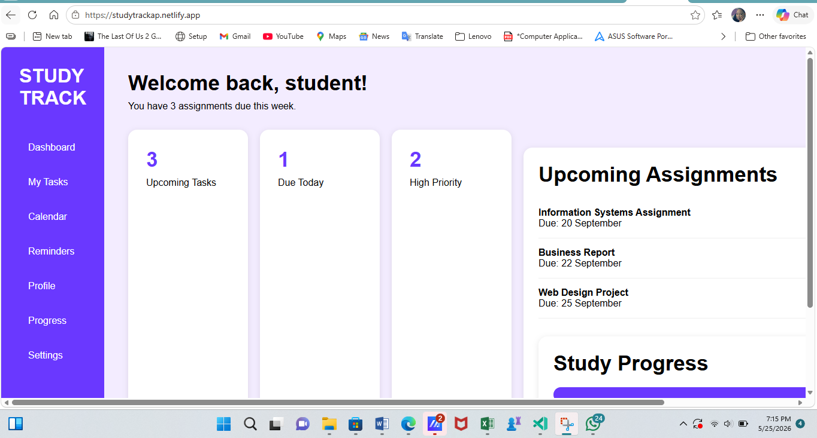
Figure 9: Published Study Track Website Accessible Online. This allows the lecturer and learners to access and test the website interactions through a live web link.
studytrackap.netlify.app

Improvements from my part 1
Usability goals have been improved by testing them in the actual prototype, where users can successfully add, view, and track assignments.
Effectiveness is demonstrated in the prototype as users are able to add assignments without errors through a structured input form.
Efficiency is improved as tasks such as adding assignments can be completed quickly within the system (under a minute in practical use).
Learnability is supported in the prototype through a simple dashboard layout and clear navigation that first-time users can easily understand.
Memorability is reinforced through a consistent interface design across all pages of the prototype.
The prototype supports the interaction types discussed in the report:
-Instructing is implemented through assignment input forms
-Exploring is supported through calendar and dashboard views
-Manipulating is demonstrated through task updates and progress tracking

